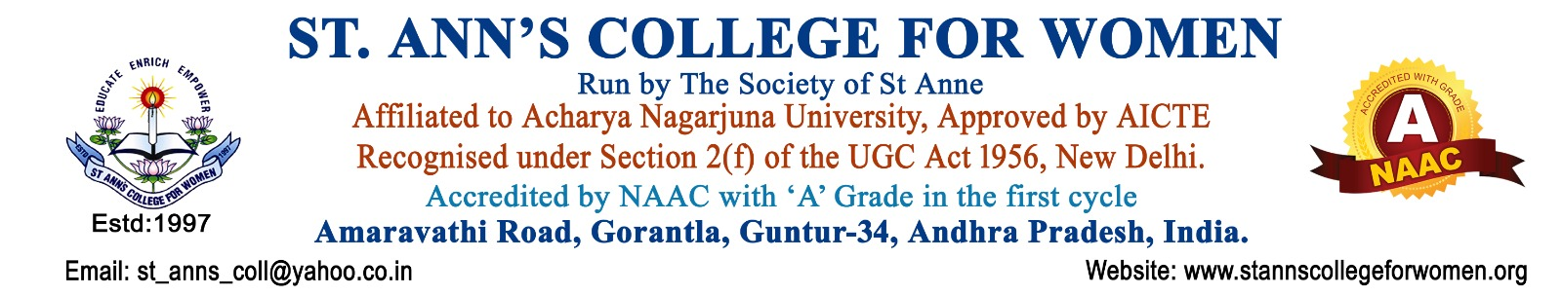

Faculty Webinar/ Workshop/ Seminars – 2024 - 2025
S.No | Name of the Faculty | Department | Title of the Webinar/ Workshop/ Seminar | Organized by (Institution) | Duration | Certificate (Yes/No)
1 | Dr.Sr.T.Sandhya | Principal/MBA | Advanced Multivariate Data Analytics for Social Sciences Research | School of Business (VSB), VIT-AP | 17-12-2024  To  21-12-2024 | Yes
2 | Dr.Sr.T.Sandhya | Principal/MBA | IFRS and Indian Accounting Standards | Department of Commerce & Business Administration, Acharya Nagarjuna University & The Association of Chartered Certified Accountants (ACCA) | 20-12-2024 | Yes
3 | Dr.Sr.T.Sandhya | Principal/MBA | Advances in Business Analytics and Intelligence | Department of Commerce and Business Administration, Acharya Nagarjuna University | 14-2-2025  To  15-2-2025 | Yes
4 | Dr.Sr.T.Sandhya | Principal/MBA | Indigenous Knowledge Systems and Sustainable Development | Shaikshik Foundation in collaboration with NCPSL & Shivaji College, University of Delhi | 9-3-2025  to  10-3-2025 | Yes
5 | Mrs. R. Sharon Rose | Vice-Principal | Implementations and Challenges of NEP-2020 in Higher Educational Institutions | Akhila Bhartiya Rashtriya Shaikshik Mahasangh (ABRSM) AP. In collaboration with School of Planning and Architecture (SPA), Vijayawada | 3-8-2024  to  4-8-2024 | Yes
6 | Mrs.G.Sailaja | Librarian | Data Protection and Data Privacy | Major Vineet Kumar, Founder, CPF, DELNET-Developing Library Network | 01-07-2024 | Yes
7 | Mrs.D.Swarna Charani Rai | HOD/Computer Science | Financial Empowerment Through Wealth Creation | St. Francis De Sales College, Electronic City, Bangalore, Karnataka, collaboration with (AMFI) | 24-01-2024 | Yes
8 | Mrs.D.Swarna Charani Rai | HOD/Computer Science | Personal Financial Planning and Wealth Creation Through Mutual Funds | Joint collaboration of Department of Economics, SECM, Martin Luther Christian University, Shieling, Meghalaya and Association of Mutual Funds in India (AMFI) | 09-10-2024 | Yes
9 | Mrs.D.Swarna Charani Rai | HOD/Computer Science | Financial Education A Life Skill Under NEP2020 | Joint Collaboration of Saketika Technical Campus, Institutions Innovation Council and Entrepreneurship Development Cell, Vizag | 05-11-2024 | Yes
10 | Mrs.D.Swarna Charani Rai | HOD/Computer Science | Intellectual Property Rights in the Era of Industry 4.0-Opportunities and Challenges | Department of Physics,  JKC College, Guntur | 26-04-2024 | Yes
11 | Mrs.D.Swarna Charani Rai | HOD/Computer Science | Planning Wealth Creation Through Mutual Funds | Joint collaboration of Department of Commerce, ICFAI University, East Khasi Hills, Meghalaya, and Association of Mutual Funds in India (AMFI) | 17-09-2024 | Yes
12 | Dr. G. Radhika | HOD/Dept. of MBA | Wealth Creation Through Financial Planning | Yogi Vemana University, Kadapa, AP, and association of Mutual Funds in India  (AMFI) | 04-08-2024 | Yes
13 | Dr. G. Radhika | HOD/Dept. of MBA | Leadership and Ethics | Department of Commerce, S.G.A Government Degree College(A), Yalamanchili | 07-08-2024 | Yes
14 | Mrs. G. Saroja | Lecturer/Commerce | Financial Empowerment and Career Opportunities in Financial and Securities Market | Department of Business Management, Palamuru University, Telangana, Association of (AMFI) | 08-08-2024 | Yes
15 | Mr. G. Bala show Reddy | Physical Director | Yoga for Holistic Development | Department of Yoga, University of College of Physical Education & Sports Sciences, ANU, Guntur | 15-3-2024  to  16-3-2024 | Yes
16 | Mr. G. Bala show Reddy | Physical Director | Digital Media - Unfolding of New Potential (DMUNP-2024) | Department of Journalism and Mass Communication, ANU, Guntur | 22-3-2024  To  23-3-2024 | Yes
17 | Mr. G. Bala show Reddy | Physical Director | Implementation and Challenges of NEP-2020 In Higher Educational Institutions | Akhila Bhartiya Rashtriya Shaikshik Mahasangh (ABRSM) AP. In collaboration with School of Planning and Architecture (SPA), Vijayawada | 3-8-2024  To  4-8-2024 | Yes
18 | Sr. G. Maragaret Priyanka | Lecturer/Bio Technology | Intellectual Property Rights in the Era of Industry 4.0-Opportunities and Challenges | Department of Physics, JKC College, Guntur | 26-04-2024 | Yes
19 | Sr. G. Maragaret Priyanka | Lecturer/Bio Technology | Implementation and Challenges of NEP-2020 In Higher Educational Institutions | Akhila Bhartiya Rashtriya Shaikshik Mahasangh (ABRSM) AP. In collaboration with School of Planning and Architecture (SPA), Vijayawada | 3-8-2024  To  4-8-2024 | Yes

